Robert Call

11/10/21

Linux Admin

**Networking Lab**

**Current Network setup for Centos**:

Step 1. To first see what your network configuration is we use the command **ifconfig**

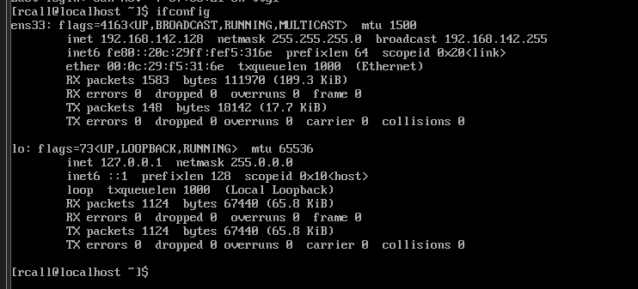

For us our Centos 8 server uses ens33 to communicate with the host machine.

Step 2. **Setting a static ip address:** On 9/19/21 we had to setup our connection this was originally an issue because the ens33 was strictly unmanaged this is because we had to alter a file by using the command **vi /etc/sysconf ig/network-scripts/ifcfg-ens33**

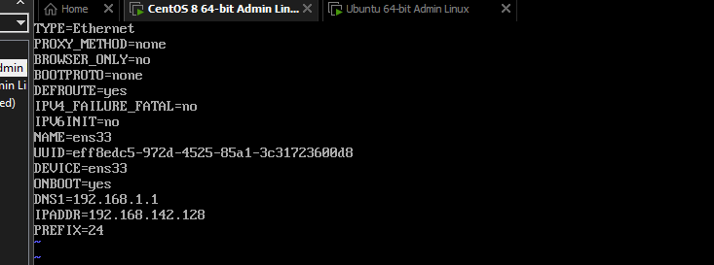

Once opened we added in the above data to make sure that this ip was static and would stay in our network to talk to the host. We do this by setting the DNS to 192.168.1.1 then set the ip address to 192.168.1.1 save the file with :wq.

Step 2. **Turning the network on**:

As this was still showing strictly unmanaged we then had to use the following command to force the network to turn on **sudo nmcli device set ens33 managed yes :** we then use the following command **nmcli device status :** this will show the network now up.

Step 3. **Setting up a static ip address:** we use the command **nmtui** this will bring up the following screen.

We hit enter and hit enter again on connection **ens33** this will let us set up a static ip like below

Make sure to set the **ipv4 configuration** to **manual** and proper address and don’t forget to select **connect automatically** then hit okay.

We now have a working static ip for our server and should be pingable from the host using **ping (ip address of the server)**

**Current Network setup for Ubuntu Server**:

Step 1. We use **ifconfig** to look at our current connector. Again, we see that ens33 is our connector to the host. Unlike our Centos 8 server we did not have to set up a configuration file.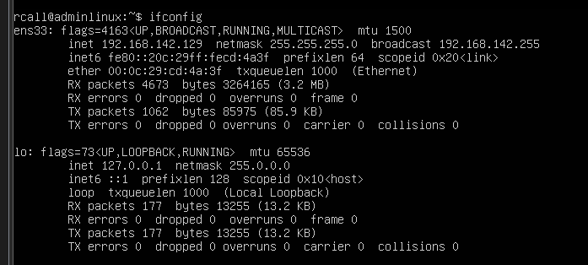

Step 2. **Setting a static ip address:** To set the server up with a static ip we first want to locate the default file for the network manager we do this by going to the file location **/etc/netplan** we use the **ls command** to see the installation file **00-installer-config.yaml**.

Then we set a backup file encase we make a mistake. With the command **sudo cp /etc/netplan/00-installer-configf.yaml 00-installer-config.yaml.bak** 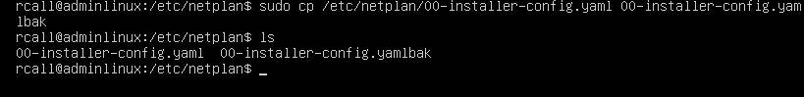

Next we will setup the static ip address by editing the file with **sudo vi** **00-installer-config.yaml**

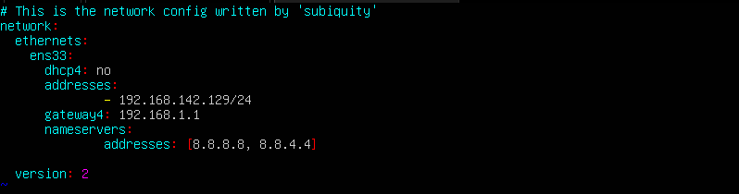

Then test it with **Sudo netplan try**  if this works press enter

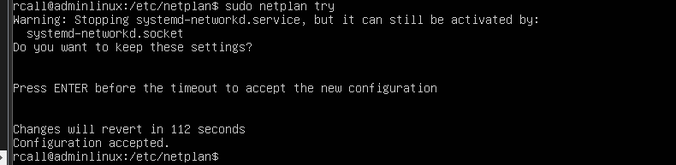

To apply this we use the command **sudo netplan apply** once done we use the command **ifconfig** or **ip a**

**Citation:**

<https://www.howtoforge.com/how-to-configure-a-static-ip-address-on-centos-8/>

<https://www.guru99.com/linux-commands-cheat-sheet.html>

https://kifarunix.com/make-permanent-dns-changes-on-resolv-conf-in-linux/